# **System Design**

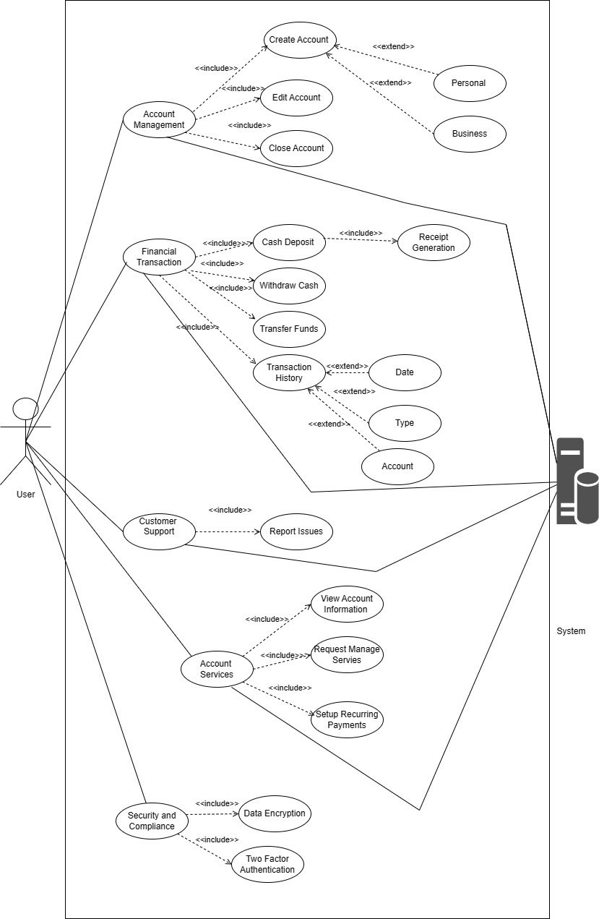

**Figure 1: Use Case Diagram of System**

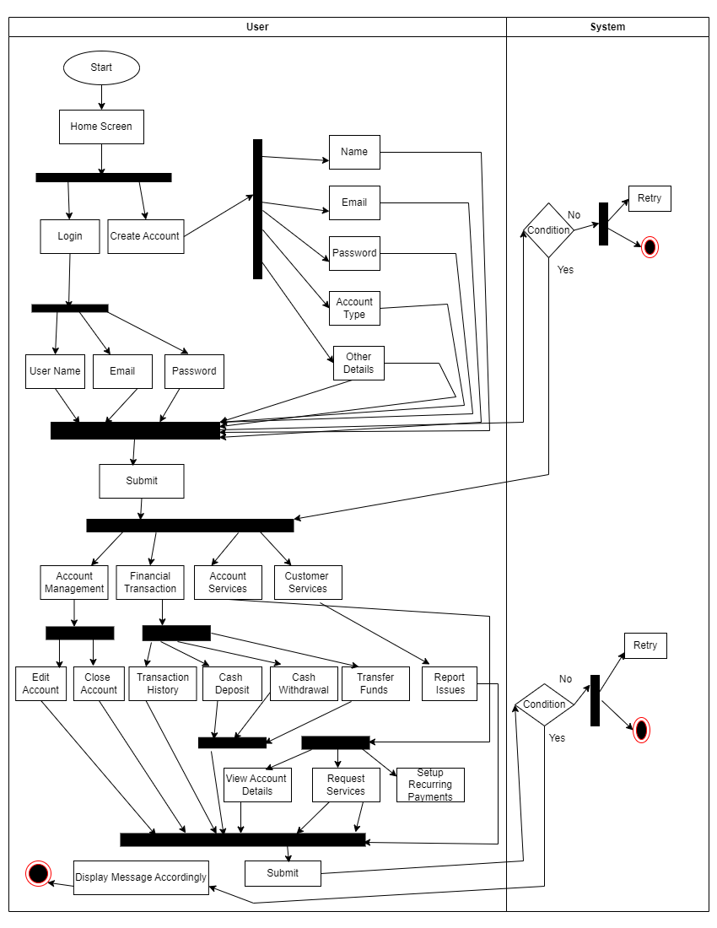

**Figure 2: Activity Diagram**

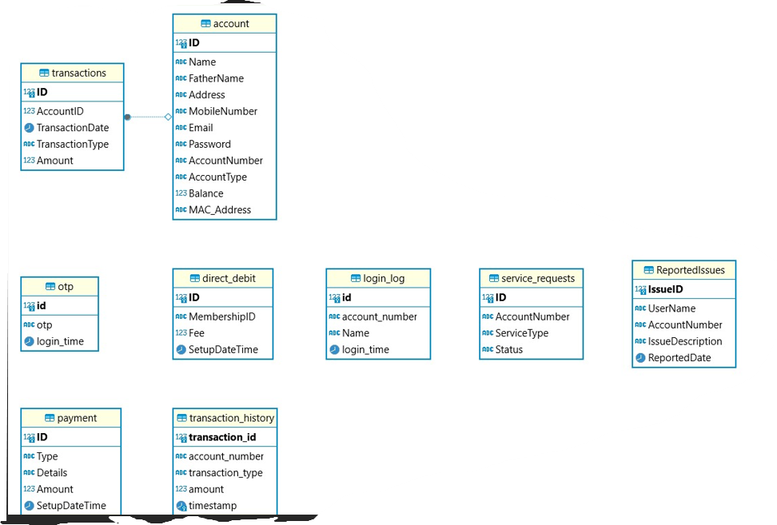

**Figure 3: ERD Diagram**

# **GUI**



**Figure 4: Home Page**

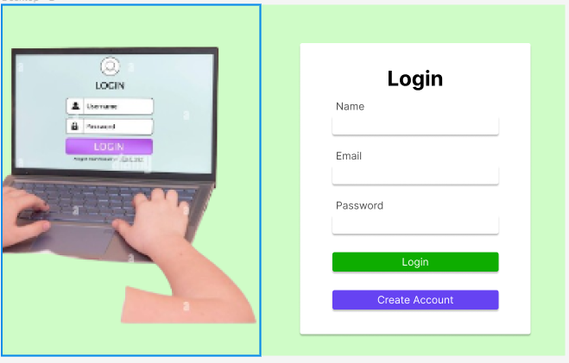

**Figure 5: Login Form**

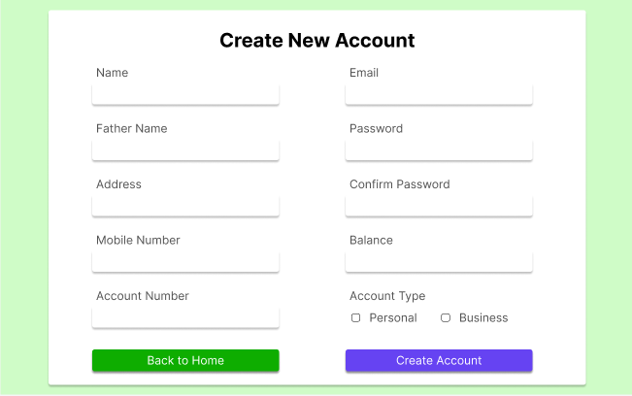

**Figure 6: Create Account**

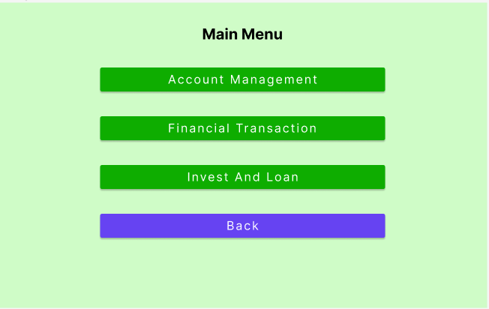

**Figure 7: Main Menu**

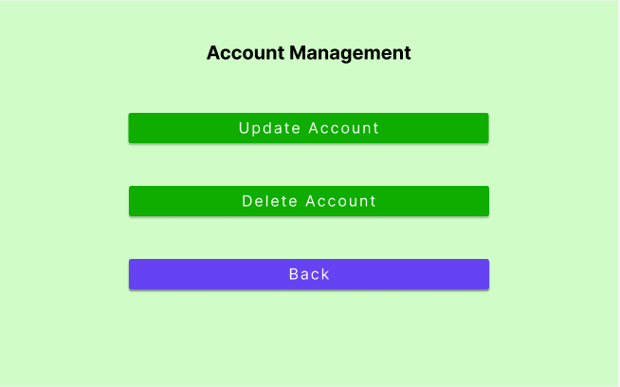

**Figure 8: Account Management**

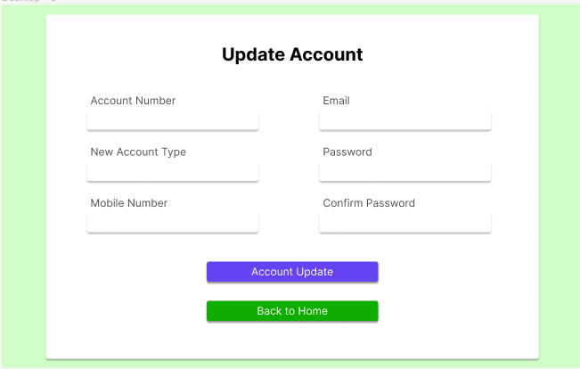

**Figure 9: Update Account**

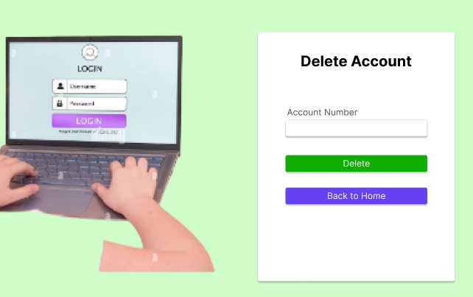

**Figure 10: Delete Account**

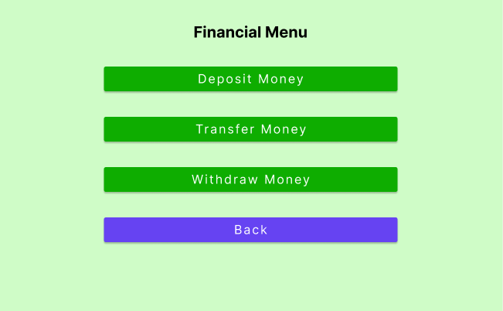

**Figure 11: Financial Menu**

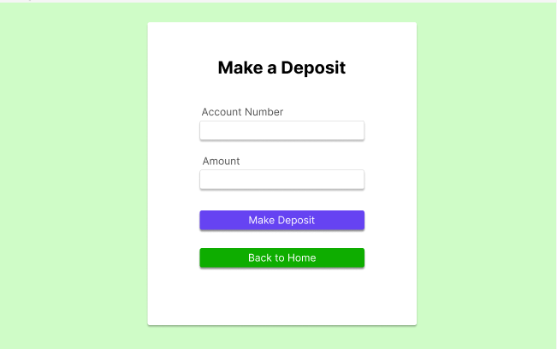

**Figure 12: Make Deposit**

# **Testing Artefact**

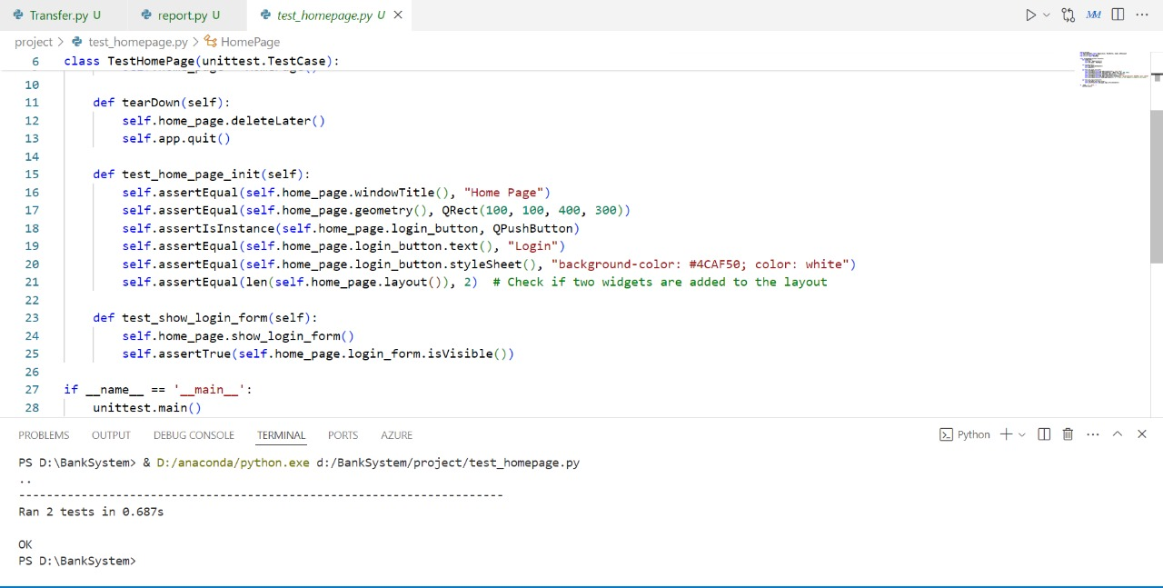

**Figure 13: Home Page**

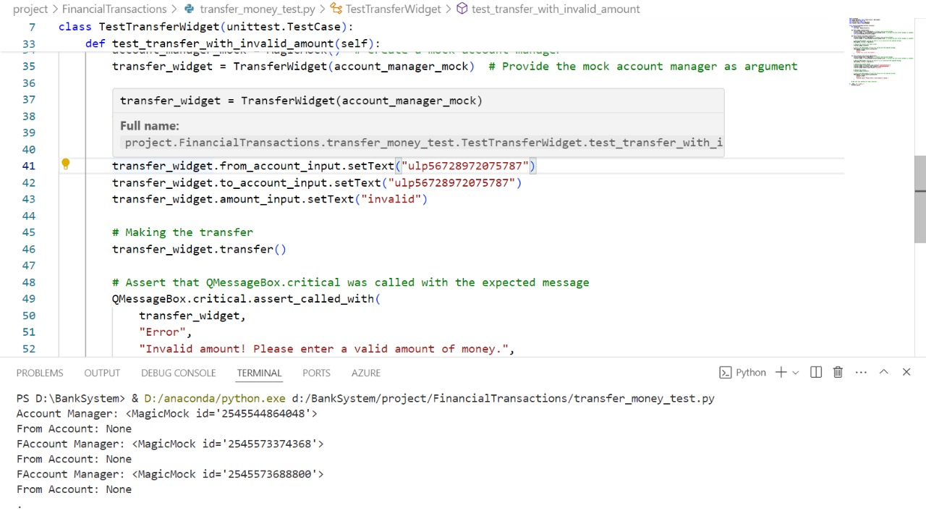

**Figure 14: Transfer Money Test**

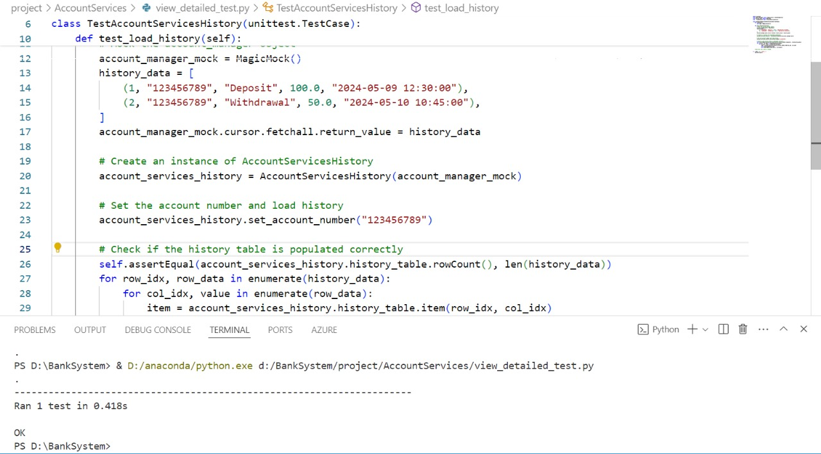

**Figure 15: View Account Detail Test**

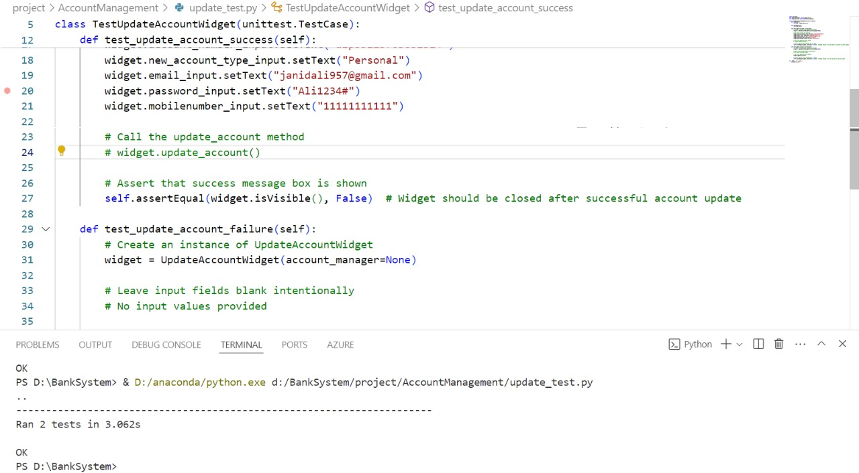

**Figure 16: Update Account Test**

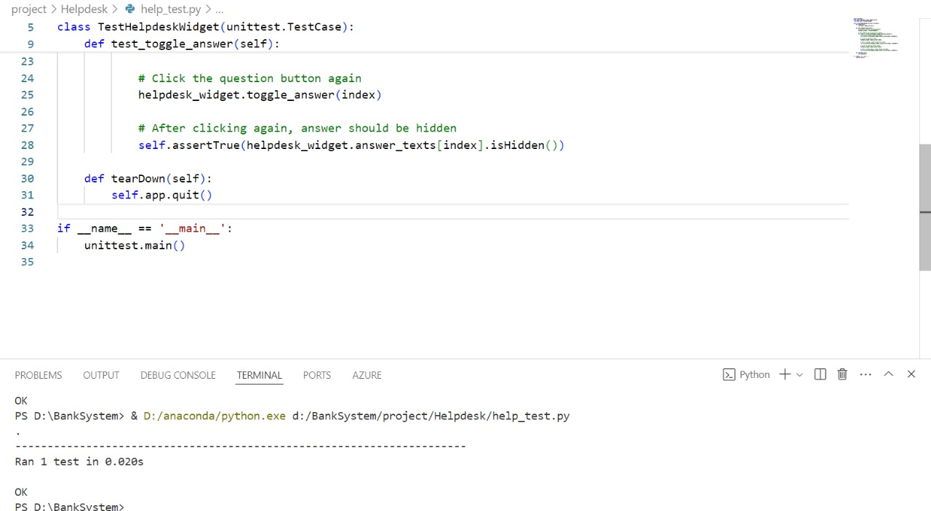

**Figure 17: Help Desk Test**